LOCAL AUTHORITY

We go to the website and launch our inspector.
Upon a login attempt:
We now have 3 new files:

Username and password to log in are visible:
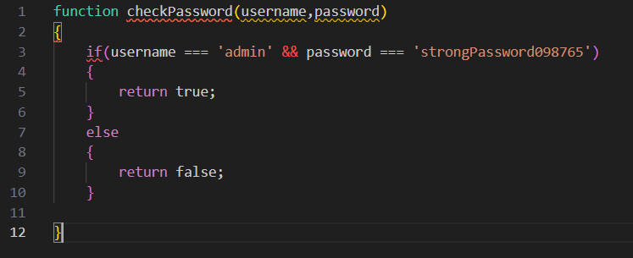
And we get our flag :
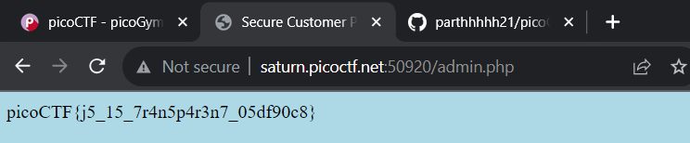

FLAG :
picoCTF{j5_15_7r4n5p4r3n7_05df90c8}

